Classifying four common hand gestures using accelerometer data from a mobile device

Hunt, A., Kumar, A., & Kumbhoje, S.

***In this paper we attempt to utilise machine learning (ML) models and recurrent neural networks (RNN) to classify four common hand gestures (1. Drawing a circle, 2. Waving, 3. Gesturing come here, 4. Gesturing go away). These gestures were recorded using the accelerometer* *sensors inside a mobile phone. Our aim here is to train the computer using the labelled data so that it can classify between different hand gestures the user performs. The raw accelerometer* *data goes through a set of preprocessing techniques such as the application of a low-pass filter, Fourier transformation and then a feature extraction and selection process to optimise the data provided for the training of the model. We have deployed ML models including Support Vector Machines (SVM), Random Forest Classifier, Extreme Gradient Boosting (XGBoost), K-Nearest Neighbour (KNN) and the Recurrent Neural Network (RNN) Models Long Short-Term Memory layer (LSTM) and Gated Recurrent Unit (GRU) looking for an optimum fit model for multi class classification between gestures.***

***The outcome shows a good, near 90%, accuracy for some ML models whilst RNN models seem to contain too much complexity in the parameters for the limited gesture data available. The simpler GRU RNN was able achieve an accuracy of 95%.***

# Introduction

Gesture recognition is a broad term is about recognising meaningful expressions of motion by a human, involving the hands, arms, face, head, and/or body [1]. Gesture recognition has a variety of applications across different fields including monitoring activities and vital signs, enhancing gaming experience, and supporting applications in robotics and wearable technology. Our intent is to use smartphones, which is a ubiquitous device, to establish communication possibilities between humans and machines, differing from the traditional data collection methods. This approach lays the foundations for further research and application of this technology to create accessibility features for individuals with disabilities, which could be a potential project within the scope of man-machine interaction.

“In recent years, gesture recognition system has become very popular in the field of research, especially facial and hand gesture recognition system” [2]. Gesture classification for hand movement can be classified into static and dynamic depending on the data acquisition method. In the past, a significant amount of research has been carried out which investigates machine algorithms like Support Vector Machine [3] [2], Random Forest [3], and Hidden Markov Model (HMM), which analyses data to discover patterns. A few Deep Learning (DL) models like CNN [3] [4] and some hybrid models like CNN-LSTM [3] mostly focus on image processing, which has now made it a common subject in the domain. However, a limited amount of research focuses on using signal data collected as a dataset using a normally accessible device among humans today.

The data we will be using for this research will be accelerometer data collected through a mobile phone. An accelerometer measures how much an object speeds up or slows down in any direction. In smartphones, these sensors are commonly used to detect the orientation of the device and to track movements, such as counting steps in a fitness app or for motion-based controls in games.

The data from an accelerometer is typically presented as readings along three axes: x, y, and z. We will also consider absolute acceleration which is the sum of all three of these values. These axes correspond to the directions in three-dimensional space, allowing the device to detect movement in any direction.

# Background

Over the years a significant amount of research has been carried out for activity recognition and for different purposes. Each study differs in the factors it considers during data collection, the types of activities performed, the nature of the dataset (whether static or dynamic [2] [4]), and the algorithms used for classifying gestures. As large data models require high volumes of input, it necessitates the requirement for selecting the right way to acquire the data. “Modern smartphones and smartwatches are equipped with sensors. Gyroscope, accelerometer, magnetometer, temperature, and sound sensors have been used for activity detection” [5]. The widespread use of mobile phones globally, along with their extensive capabilities, was considered for their potential to act as remote controllers. The data was collected using the Phyphox[1] application compatible on both android and IOS devices and the study integrated accelerometer data from four different human activities, similar to Odhiambo, Chrisogonas Odero et al. [6].

The static time series 3D dataset was then explored for multi class classification. “The most adopted classifiers included the k-nearest neighbour (KNN), random forest (RF), multilayer perceptron (MLP), support vector machine (SVM), decision tree, and artificial neural network (ANN),CNN [5]”. However, DL algorithms worked best on raw normalised data. Next, the algorithm selection which depends on the variety of data to be processed . For image-based data algorithms like CNN, CNN-LSTM are suggested. SVM [3] [2] [1], RF [3] were discovered as the most popular ones for gesture classification, the best results in precision-recall-FI (abbr.: P-R-F1), followed by the KNN and LR [8]. The popular models among the DL were RNN’s GRU.

# Methodology

To achieve our aims of producing a classification model for four gestures (come, go away, wave, and circle), the raw accelerometer data is pre-processed and undergoes several key transformations to contribute to the classification process. Only the most useful features are taken through to the model training phase.

## Data Collection

Data was collected using the Phyphox mobile application. Each member of the team performed the same four gestures for eight iterations per recording, and five recordings each per gesture – 40 iterations per person per gesture for a total of 480 complete gestures.

These gestures were initially recorded continuously, without stopping, as per the coursework specification but after trial and error we discovered that segmenting the data was a lot more difficult when there were no clear spaces between the gestures. Instead, we opted to leave a distinct one second gap between performing each gesture in each recording. Adding these pauses allowed us to segment the recording more easily into its separate gesture patterns.

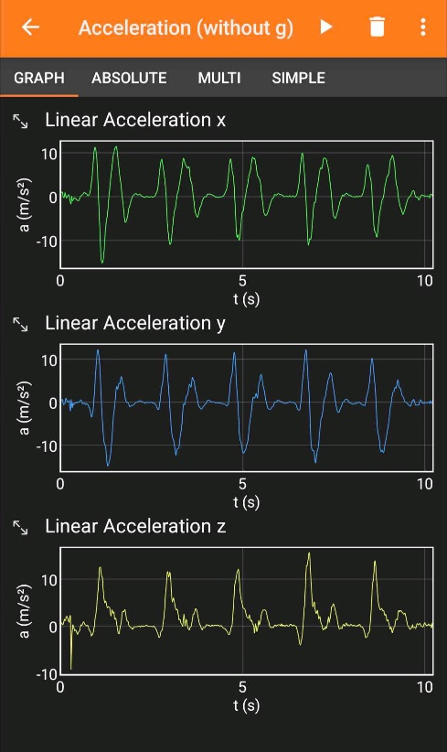

Figure 1: Screenshot of the Phyphox recording interface.

This raw accelerometer data was then exported into a csv file with a row for each sensor reading. The sampling frequency was approximately 60 Hz.

We imported two separate data sets, one for testing and training and the other for validation. Both data sets would undergo the same pre-processing, but we would apply a *train_test* split to the first and the second would be kept away from the model until we needed to perform validation on the model performance.

## Data Exploration

Once the data was recorded and the associated csv files were imported into a *pandas* *DataFrame* we applied a basic trim to the data. We would inspect, from the beginning of the file, every 20 data points and if the mean acceleration over that sample was < 0.3 then the data was removed. We did this from the beginning of the file as well as the end of the file. This would help us reduce unnecessary noise at the beginning and end of the file, making segmentation easier.

We then began to explore the data by inspecting the raw sensor data and creating visualisations of the data. These visualisations would allow us to understand the data and what features of the data would play a significant role in classification.

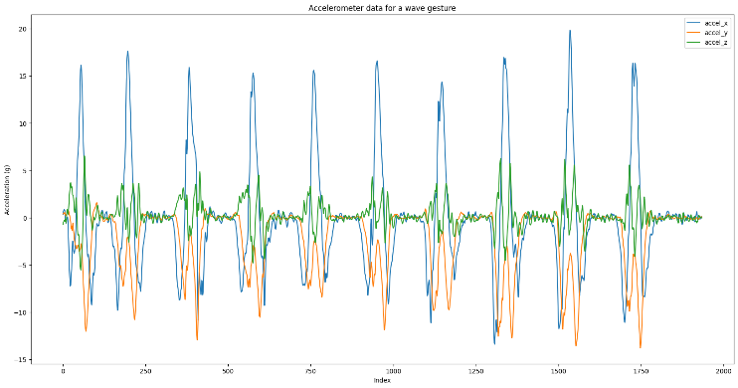

Figure 2: Raw accelerometer data for a wave gesture recording.

## Data Pre-Processing

To balance the dataset, ensuring that the model would not prioritise one gesture, we found which gesture had the least number of recordings and then dropped all recordings greater than that number. This step would ensure that each gesture contributed equally to the model training.

To begin our pre-processing, we used the *scipy.signal* *butter* and *filtfilt* functions, applying a low-pass frequency filter to the data. This filter would apply dampening to the sensor data and reduce noise. Visually, this made the waveforms smoother and less jittery. Filtering ensures that the model does not overfit based on the noise in the system but uses the more generic shape of the data. After several experiments we decided on a cutoff frequency of 3 Hz, a sampling rate of 150 Hz and a filter order of two.

We also applied an exponentially weighted moving average (EWMA) filter at this stage. EWMA filtering was performed so that spikes in the data were dampened. This dampening was especially important when considering recordings that contained many different types of gestures as some gestures tended to have much higher acceleration than others, simply due to the nature of the gesture. A span value of ten was used for this filter as it dampened the spike in signals without compromising the overall shape of the gesture.

Next, we applied a Fourier transformation to the data using *numpy Discrete Fourier transform (FFT)*. Fourier transformation can be used to decompose a signal into its underlying frequencies, which can be useful for removing noise from the accelerometer data as well as determining the most important parts of the signal that define the gestures. Applying this Fourier transformation filtering in this way meant that the signals were more uniform and less prone to noise. It was expected that a simpler wave signal would translate into a more accurate and reliable model.

Human motion generally falls below 20 Hz, which includes most daily activities and deliberate gestures. But in order to fully understand the makeup of the accelerometer data we conducted a frequency spectrum analysis using FFT.

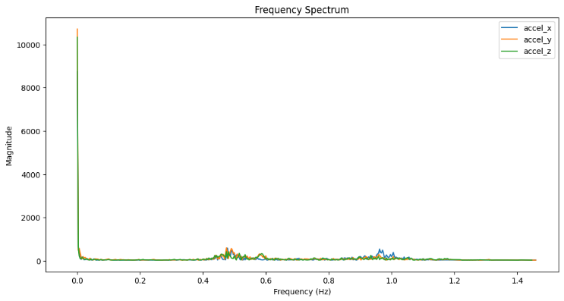

Figure 4: Accelerometer data spectral analysis using Fourier transformation.

The spectral analysis revealed that most of the data was composed of 0 Hz data and seemingly all the useful data was < 1.2 Hz. Using this information, we were able to apply a FFT filter to our data using a low cut-off frequency of zero and a high cut-off frequency of 1.5 Hz, and of course of sample rate for this would be 60 Hz as per the sensor recording sampling rate.

Figure 3: Example gesture data before and after Fourier transformation and filtering.

Dynamic time warping (DTW) can also be used to find the similarities/distance between different wave signals, which can be used to shift rotate the waves so that slight misalignments in the time domain are not factors in the segmentation and eventual feature extraction of the gestures. DTW was considered a stretch goal for the project but was not implemented.

## Segmenting the Data

The next step of processing was to separate the individual gestures from the files that contained six to nine gestures of the same type. This would be required so that each gesture was separated in its own block of data to be associated with a label. Our first attempt to apply this separation was to visually inspect the data and its rolling average and deviation – this would help us identify an appropriate value to decide on when one gesture was starting, and another was ending.

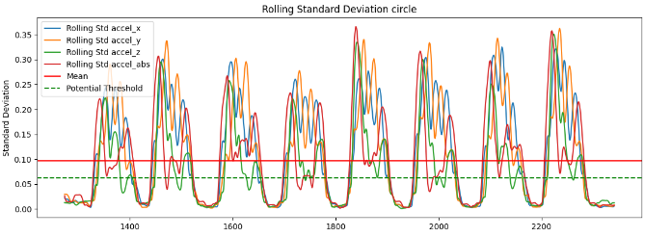

Figure 5:Rolling standard deviation of a circle gesture recording.

This figure outlines our suggested splitting point (any points where the acceleration standard deviation is lower than the threshold, in green). Using these points, we could segment the file into its separate gestures ready for feature extraction.

An alternative approach was then adopted where we utilised *scipy.signal find_peaks* to automatically detect peaks in absolute acceleration, and from those peaks expand its boundaries until the acceleration was below some threshold, indicating the end of the gesture.

Figure 6: Absolute acceleration graph for a circle recording, showing the peaks in the data that represent the gestures.

We could then visually inspect the gestures to ensure that the segmentation was being correctly applied.

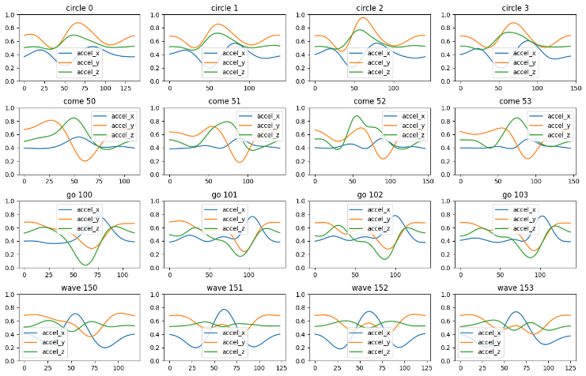

Figure 7: A preview of the segmented gesture data.

Once the gestures were separated, we once again performed dataset balancing to ensure that each gesture had an equal number of observations and did therefore not contribute more to the model training.

## Normalisation

We then applied a *scikit-learn* *MinMaxScaler* to the data – which transforms the data to values between 0 and 1 whilst maintaining the relationships between the datapoints. This transformation is achieved using the below formula:

$$x_{scaled}=\frac{x-x_{min}}{x_{max}-x_{min}}$$

We performed this transformation to ensure that the machine learning models did not perceive higher values as more important for training.

## Feature Extraction

Processing every row of the gesture accelerometer data would require substantial computational resources and may also increase the complexity of the model, which can lead to overfitting. Feature extraction helps reduce the dimensionality of the data by extracting the most relevant features, thus simplifying the models while retaining the essential information and achieving generalisation. “SVM usually needs careful feature extraction and selection, as well as other traditional ML algorithms like naïve Bayes (NB), K-nearest neighbours (KNN), and decision tree (DT). HMM is memoryless and unable to use contextual information” [7].

To achieve this requirement, we would segment the data, this time with each gesture being broken up into $n$ distinct sections with some overlap. We experimented with several different values for the number of segments and the overlap between segments. The optimal value was discovered to be 8 segments. The overlap between segments did not seem to play a large role in the overall performance, we therefore decided to stick with a 50% overlap as recommended by Akhavian and Behzadan [9].

We could extract key features from each segment, such as mean, standard deviation, median, skew and kurtosis. This mapping would result in data that is a summary of each slice of the gesture. These features could then be visualised and taken through the feature selection process.

## Feature selection

Once all features were extracted, we visually inspected the averages of the features to find those that had the clearest disparity between the gestures. Feature selection is critical to reduce the computational and time cost of classification, as well as increase the models’ accuracy.

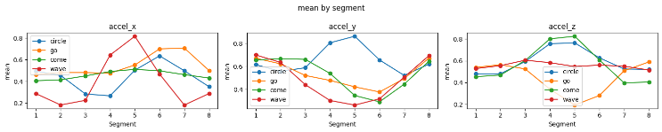

Figure 8: Feature visualisation for the standard deviation of each segment.

Originally, we had planned to use these visualisations to find features that provided clear separation between the gestures and to drop the features that did not provide strong correlation. However, this process allowed room for ambiguity and did not allow easy automation. Instead, principal component analysis was used to automate the process of feature aggregation and selection.

Figure 9: Principal component analysis visualisation for n=3.

After experimenting with various values of *n*,the accuracy for model training was best when the dataset was reduced to just two components.

After applying principal component analysis, k-means clustering was utilised to ascertain how well the PCA reduced feature set could be clustered. This visualisation would allow us to see how well the clusters were separating the data based on different values for *n*.

Figure 10: K-means clustering visualisation for four gestures.

## Train/Test/Validation Data Splitting

Before we began training the models we split our data using *sklearn train_test_split.* This function would split our data into data for training our model and then keep separate data for testing our model. Ensuring that the test data remains completely unseen by the model during training is critical. Data leakage can occur if any step prior to model training involves knowledge about the test set. This can lead to overfitting and falsely optimistic performance metrics.

## Model Selection

Based on our initial research of similar papers, we had created a shortlist of potential models to evaluate for our requirements. Firstly, we considered machine learning models and then neural networks.

### K-nearest neighbours (KNN)

KNN is very simple to understand and implement. The algorithm classifies new data points based on the majority vote of the k nearest points in the feature space. This makes it a straightforward choice for initial experimentation and prototyping. KNN is also an effective classifier when dealing with small datasets such as ours, due to the limited number of gestures we could record.

### Random Forest

A *RandomForestClassifier* was used with a predefined random state for reproducibility. Grid search was applied to fine-tune hyperparameters such as the number of estimators, maximum depth, minimum samples split, and minimum samples leaf. Cross-validation (cv=3) was used with balanced accuracy as the scoring metric.

### Extreme Gradient Boosting (XGBoost)

In our exploration of suitable models for gesture recognition using accelerometer data, XGBoost emerges as a strong candidate. XGBoost, or Extreme Gradient Boosting, is an implementation of gradient boosted decision trees designed for speed and performance. It is particularly well-suited for handling non-linear relationships and complex patterns in data, characteristics often present in gesture recognition tasks. Furthermore, XGBoost includes built-in regularisation, which helps prevent overfitting, a common challenge in machine learning scenarios involving complex models and limited data.

### Long Short-Term Memory layer (LSTM)

LSTM is a RNN which is used for sequence prediction, such as involving time-series data. LSTM can capture temporal dependencies which make them effective for gesture recognition tasks. In our implementation, we pre-processed the data and encoded the gesture labels using *LabelEncoder* to convert them into numerical labels. Subsequently, the number of time steps of windows representing the quantity of previous time steps of data that will be utilised to predict the current gesture is defined. The data is then prepared for model training using a custom function which generates sequences of data samples based on the time steps defined earlier.

LSTM sequential model is built using *Keras,* which consists of two LSTM layers with 50 neural units each followed by a Dense layer having SoftMax activation for multi-class classification. Next the model is compiled using the Adam optimiser and sparse categorical cross entropy loss function. The model is then trained and validated using the training and validation set.

### Gated Recurrent Unit (GRU)

Unlike traditional machine learning models that treat data points as independent, LSTM and GRU can learn from the progression and duration of gestures as represented by the time-series data from accelerometer sensors. This capability allows them to minimise the impact of temporal gaps and variances in gesture speed. Zhang et al. [9] explain that one of the most recent deep learning algorithms that can successfully analyse dynamic input is the GRU [10].

Furthermore, GRU offers a more streamlined architecture that requires fewer parameters than LSTM, potentially increasing computational efficiency without significantly sacrificing model performance. A simpler model with fewer parameters is also a good property since we only have limited gesture data. By leveraging these models, our approach can more accurately and robustly classify the gestures.

# Results

Several machine learning models achieved a high (near 90%) validation accuracy whilst the deep learning models struggled with the limited amount of data that was available.

### K-nearest neighbours (KNN)

Utilising the best hyperparameters found:{'knn__metric': 'euclidean', 'knn__n_neighbors': 3, 'knn__weights': 'uniform'} an accuracy of 0.98 was achieved on testing data and 0.87 on validation data.

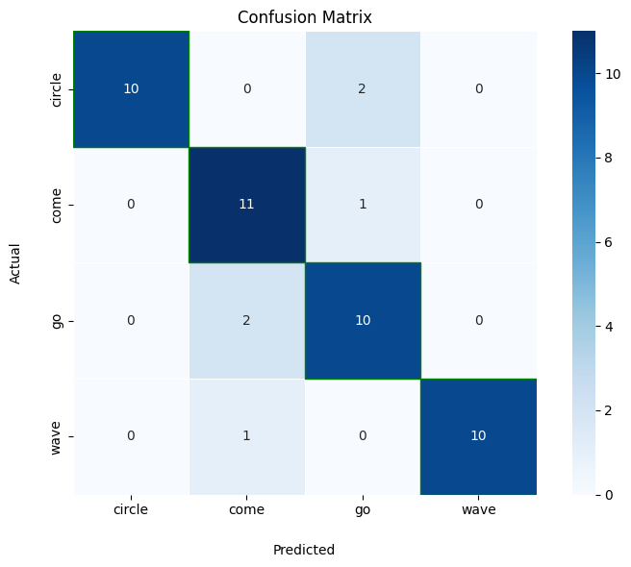

Figure 11: KNN validation results confusion matrix.

### Random Forest

The best parameters obtained from the grid search were {'n_estimators': 250, 'max_depth': None, 'min_samples_split': 10, 'min_samples_leaf': 2}. The optimal model was then used to predict gestures on the testing set. The test set achieved a balanced accuracy of 0.98, thereby providing an indication of the model's overall predictive ability. For validation this accuracy was reduced to 0.85.

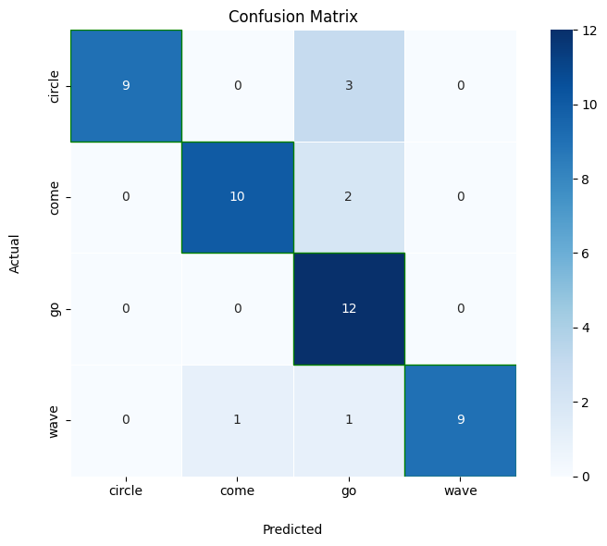

Figure 12: Random Forest validation results confusion matrix.

### Support Vector Machines (SVM)

The data was pre-processed and a grid search with cross-validation was carried out to optimise the SVM's hyperparameters, focusing on the regularisation parameter C, kernel type, and gamma value. The optimal parameters were C=0.1, using an 'rbf' kernel, and 'scale' for gamma.

After training, the SVM model achieved a balanced accuracy of approximately 0.98 on the test set, indicating its ability to generalise to unseen data. On validation data this accuracy was reduced to 0.89.

It is worth noting that the process involved substantial computational resources, and attempts were made to fine-tune the parameters by experimenting with various kernel types and C values, but these adjustments did not yield significant improvements in performance.

Overall, accuracy for SVM model has shown its potential for gesture classification, although further exploration, feature engineering, or alternative algorithms could be considered to enhance accuracy further.

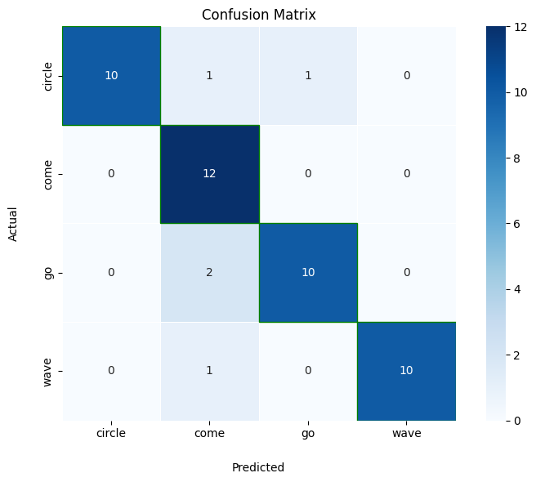

Figure 13: SVM validation results confusion matrix.

### Extreme Gradient Boosting (XGBoost)

A grid search was performed to optimise the hyperparameters of the XGBoost model. The parameters used were number of estimators (trees) in the ensemble, maximum depth of each tree, learning rate, and subsampling ratio. The best parameters identified through the grid search were an ensemble of 300 trees with a maximum depth of 20, a learning rate of 0.1, and a subsampling ratio of 0.8.

After training, it achieved a balanced accuracy of approximately 0.98 on the test set. This performance indicates the model's ability to classify gestures based on the features. On the validation data this accuracy decreased to 0.85.

In comparison to SVM, the XGBoost model demonstrated only a slightly lower balanced accuracy, suggesting its potential as a robust classifier for gesture recognition. Further exploration could involve feature engineering, or additional parameter tuning to potentially enhance classification performance even further.

### Gated Recurrent Unit (GRU)

The optimal parameters found were: { epochs: 25, batch_size: 10, timesteps: 2 }. Using these parameters the GRU model achieved an accuracy 0.95 on training data. The model was seeded using the value 38.

### Long Short-Term Memory layer (LSTM)

The optimal parameters found were: { epochs: 10, batch_size: 32, timesteps: 10 }. Using these parameters the LSTM model achieved an accuracy 0.33 on training data.

# Discussions

The model with the highest accuracy was SVM with 0.89 validation accuracy, closely followed by KNN and RF. As outlined in the results section, machine learning models outperformed the deep learning models, but this was likely due to the limited number of data samples that we had collected. It is expected that with more gesture data we could achieve accuracies over 90% with deep learning models such as LSTM.

To gain more accuracy with our models we think that we would need to improve our gesture segmentation process to ensure that the entire gesture is segmented correctly, even when there is distortion in the accelerometer data or excessive noise. Alternatively, by using temporal models such as LSTM with larger data sets, we would eliminate the need for gesture separation at all.

Another way in which we could improve our model’s accuracy is with an alternative feature extraction method. Whilst manually extracting features that looked visually different from others was too imprecise, principal component analysis could have reduced the dimensionality of the dataset too drastically. Akhavian and Behzadan [9] used two other methods for feature extraction: ReliefF and Correlation-based Feature Selection (CFS). ReliefF ranks features based on their ability to distinguish classes and CFS is a search algorithm that assesses the correlation between features and classes. They first applied CFS to remove redundant features and then took the top *x* features by using ReliefF. This allowed them to select their feature dimensionality whilst ensuring that only the most appropriate features were used.

Higher accuracies could also be achieved by aligning the gesture signals using dynamic time warping of the signals, which would improve the feature extraction and the overall representation of the gestures.

# Conclusion

In this study, we have demonstrated the viability of using standard mobile device sensors for the accurate classification of hand gestures, achieving significant success with several machine learning models.

Classifying gestures from mobile device sensor can be difficult due to the variation in movement that is possible from user on a mobile device and the number of ways in which a gesture can be expressed, both by the individual and by the digital representation of it.

When working with a limited dataset, machine learning models such as RF, SVM and KNN will provide approximately 90% accuracy when classifying gestures into four distinct classes.

Ultimately, the continued refinement of these technologies holds the promise of making seamless gesture-based communication a commonplace reality, offering a more natural and engaging way for individuals to interact with technology.

# References

|  |  |
| --- | --- |
| [1] | M. Sushmita and T. Acharya, “Gesture Recognition: A Survey,” IEEE, 2007. |
| [2] | H. Rahman and J. Afrin, “Hand Gesture Recognition using Multiclass Support Vector Machine,” *International Journal of Computer Applications,* p. 6, 2013. |
| [3] | S. Moccia, S. Solbiati, M. Khornegah, F. F. Bossi and E. G. Caiani, “Automated classification of hand gestures using a wristband and machine learning for possible application in pill intake monitoring,” *Computer Methods and Programs in Biomedicine,* p. 10, 2022. |
| [4] | Z. Islam, M. Shahadat Hossain, R. Islam and K. Andersson, “Static Hand Gesture Recognition using Convolutional Neural Network with Data Augmentation,” IEEE, USA, 2019. |
| [5] | U. A. Siddiqui, F. Ullah, A. Iqbal, R. Ullah, S. Paracha, H. Shahzad and K. S. Kwak, “Wearable-Sensors-Based Platform for Gesture Recognition of Autism Spectrum Disorder Children Using Machine Learning Algorithms,” 2021 May. |
| [6] | L. Ablonczy, P. J. Wright, . C. F. Corbett, S. Reichardt, H. Valafar and C. O. Odhiambo, “Detecting Medication-Taking Gestures Using Machine Learning and Accelerometer Data Collected via Smartwatch Technology: Instrument Validation Study,” JMIR HUMAN FACTORS, ., 2023 May. |
| [7] | S. Zhao, H. Cai, W. Li, Y. Liu and C. Liu, “Hand Gesture Recognition on a Resource-Limited Interactive Wristband,” 2021. |
| [8] | I. Stancic, J. Music, T. Grujic, M. K. Vasic and M. Bonkovic, “Comparison and Evaluation of Machine Learning-Based Classification of Hand Gestures Captured by Inertial Sensor,” 2022. |
| [9] | A. Ahmad Ilham, I. Nurtanio, Dr Ridwang and Syafaruddin , Applying LSTM and GRU Methods to Recognize and Interpret Hand Gestures, Poses, and Face-Based Sign Language in Real Time. Journal of Advanced Computational Intelligence and Intelligent Informatics, 2024. |
| [10] | P. Zhang, Z. Li, H. Zhang, . J. Ding, X. Zhang, R. Peng and Y. Feng, “Simulation model of vegetation dynamics by combining static and dynamic data using the gated recurrent unit neural network-based method,” *International Journal of Applied Earth Observation and Geoinformation,* vol. 112, no. 102901, 2022. |
| [11] | D. A. Maharani, H. Fakhrurroja, Riyanto and C. Machbub, “Hand gesture recognition using K-means clustering and Support Vector Machine,” 2018. |
| [12] | S. Ari and D. Kumar Ghosh, “Static Hand Gesture Recognition Using Mixture of Features and SVM Classifier,” 2015 Fifth International Conference on Communication Systems and Network Technologies, Gwalior , India, 2015. |
| [13] | S. Kumar, N. Zal Tarapore, V. Mohile and T. J. Joshi, “Static Hand Gesture Recognition using an Android Device,” International Journal of Computer Applications, 2015. |
| [14] | Z. Yang and X. Zheng, “Hand Gesture Recognition Based on Trajectories Features and Computation-Efficient Reused LSTM Network,” *IEEE Sensors Journal,* vol. 21, 2021. |
| [15] | A. Toro-Ossaba, J. Jaramillo-Tigreros, J. C. Tejada, A. Peña, A. López-González and R. A. Castanho, “LSTM Recurrent Neural Network for Hand Gesture Recognition Using EMG Signals,” 2022. |
| [16] | Y. N. Wohn and K. Yun, “Recognition of space-time hand-gestures using hidden Markov model,” New York, 1996. |

1. https://phyphox.org/